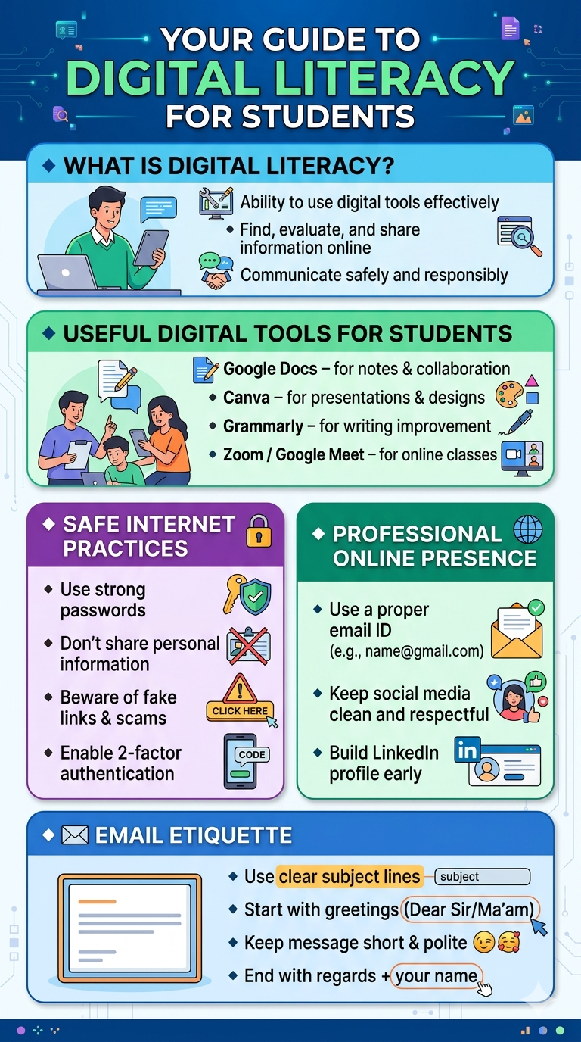 The digital literacy poster was generated using the DALL-E 3 text-to-image model. The clean, modern, infographic-style design is titled “YOUR GUIDE TO DIGITAL LITERACY FOR STUDENTS” against a deep blue background with subtle glowing digital circuit patterns. The poster is structured into five distinct, color-coded rounded panels, each dedicated to a critical aspect of being digitally adept. It includes illustrative icons for every bullet point: definitions of literacy (finding and evaluating info), useful student tools like Google Docs and Canva, essential security tips (strong passwords, 2-factor authentication), advice for building a professional online profile on platforms like LinkedIn, and a guide to professional email etiquette.
One particularly interesting element observed during the creation process was the tool’s exceptional context awareness in rendering the specific tool icons, such as the distinct green pen icon for Grammarly and the artist’s palette for Canva. Text handling, often a major challenge for AI image generation, was flawless; every list item, including the complete email address example, is spelled correctly and legible, significantly boosting the image’s immediate instructional value.

